**Snap 7 Server Enhanced user manual**

## By Marco Bo and Lorenzo Bardi

Snap 7 Server Enhanced extends the functionalities of the Snap 7 Server loaded in the official website project. In this application you can directly import the db export file containing all the selected DBs of your PLC project from TIA Portal using a little trick. It will convert the db export file in an XML file used by the internal engine to create the DB structure and simulating a S7 DB list accessible via S7 connection or Snap7 Client. You can also edit DB variables in the server side using the application GUI.

**Part 1 – Procedures on TIA Portal**

DB selected must NOT be optimized so you need to DISABLE “Optimized Access” on the properties section.

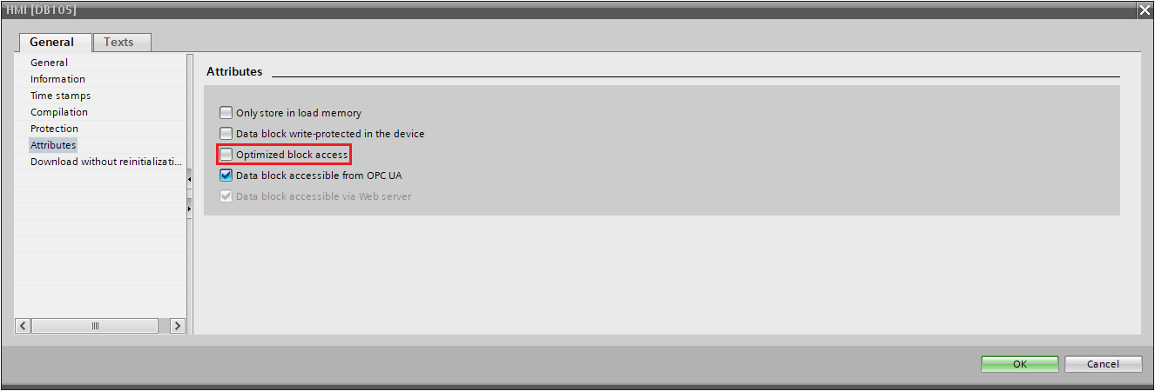

The db export file generated by TIA Portal normally does not keep the number of the DB so we’ve decided to use the User-ID attribute on the DB properties section in order to avoid this issue.

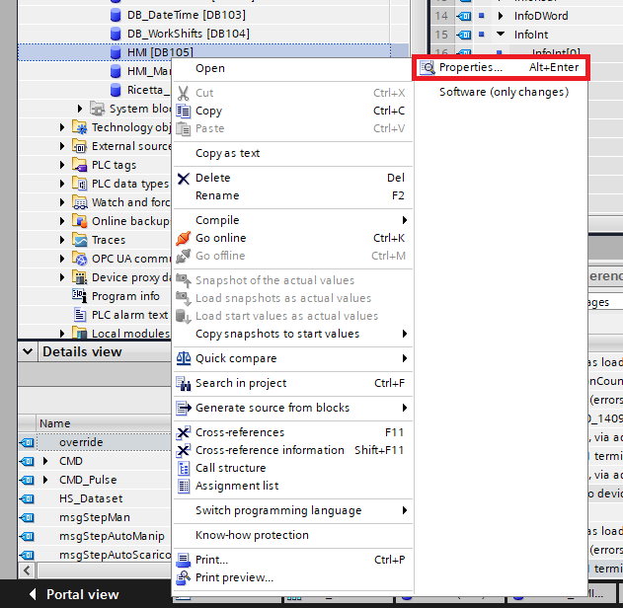

Manually adding this attribute will save the DB number on the db file export.

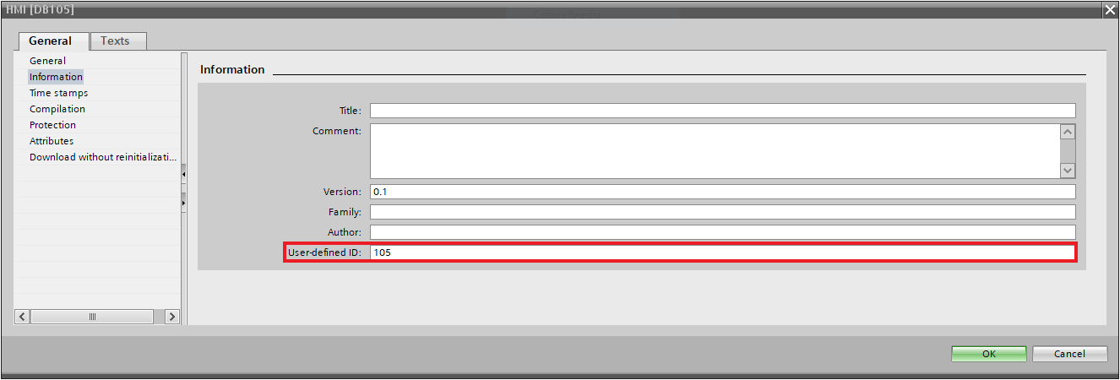

Now you can export the DBs including all dependent blocks as db file. Right click on the interested DBs (multiple selection)/Generate source from blocks/Including all dependent blocks.

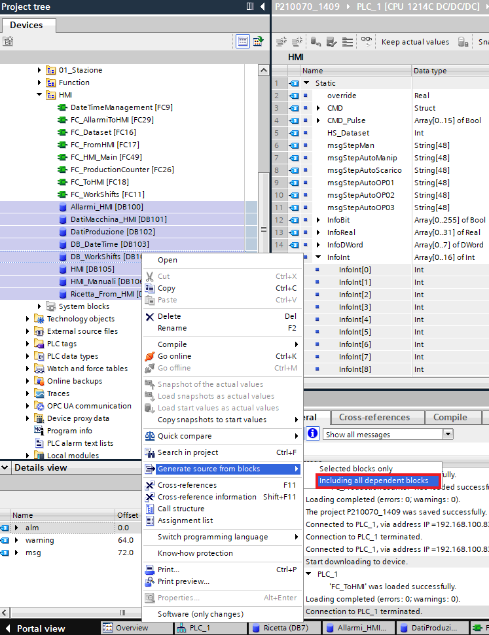

The following picture shows a part of the db file exported. The row highlighted identifies the User-ID attribute added previously as the DB number.

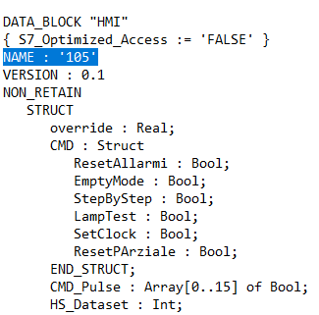

**Part 2 – Load the db export file on the application**

When you launch the application a dialog will be shown. Click on “Search” button to browse a system path. Otherwise, for automation purposes, you can pass the xml path as first executable argument and this form will not appear anymore launching automatically the server control GUI.

If you pass START as second executable argument the server will start automatically.

(E.g. C:\MyFolder\Pmy_server_snap7_enhanced.exe /”XML file path” /START)

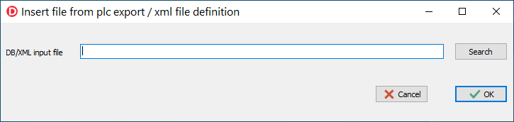

Select the interested db export file or an xml generated file from our application (generated in a previous session) and click “Open”. 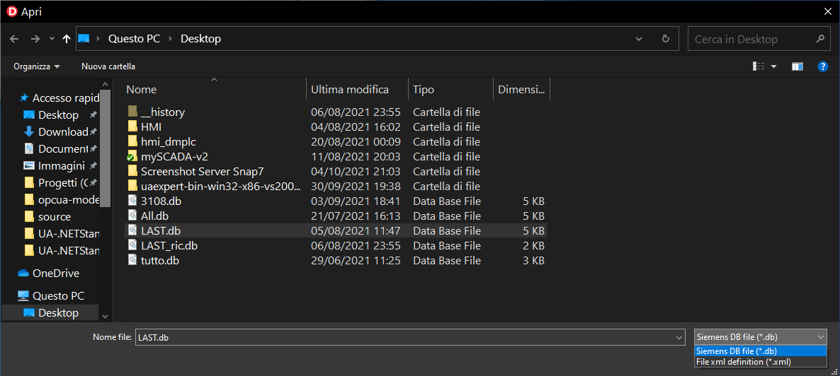

If the xml already exists in the specified path a dialog will be shown asking to overwrite the file.

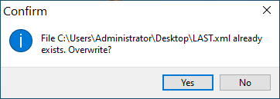

It will appear the server control GUI.

On the left side we have the server control sidebar: Start and stop button to start and stop the server thread, IP to select what adapter bind and the “enable connect / disconnect every 20 seconds” checkbox. This checkbox keeps the server connected for 20 seconds and then it will disconnect it for 20 seconds cyclically. It can be useful to check your SCADA behavior during a reconnection.

The bottom side is composed by a memo box where all the log will be written during server activities. In the middle you can find the tab container with the “Log Mask” tab sheet selected. Inside this tab sheet you can find all the events to include/exclude from the log.

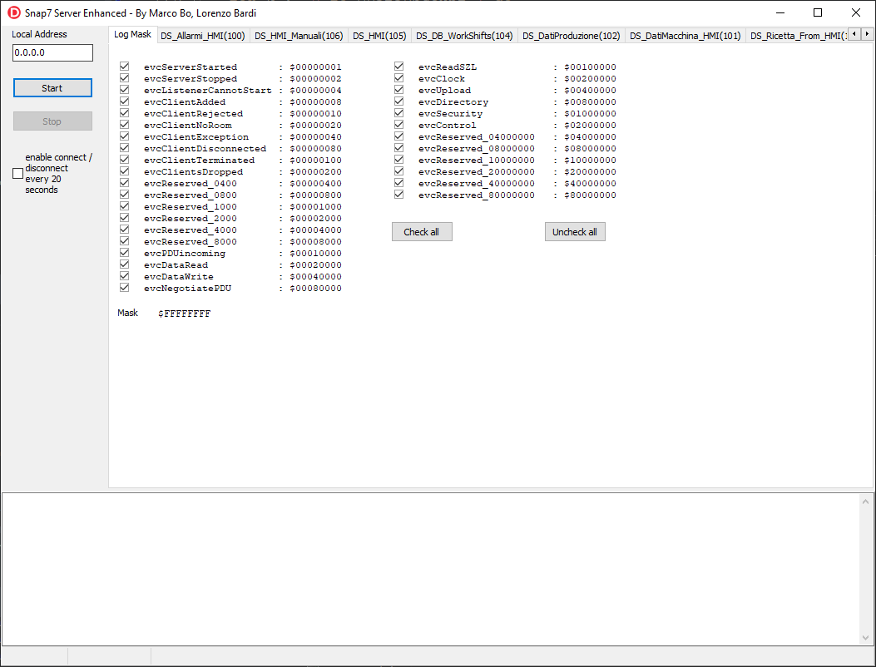

All the other tab sheets contain the Siemens DBs loaded from the TIA Portal db export file.

A DB tab sheet is divided by the upper part containing a table and a lower part containing the DB tree. The table has 3 fields: Variable name, Type and Value. “Variable name” shows the Siemens variable name, “Type” describes the type of variable (Bool, Byte, Int, Real, etc) and “Value” shows the actual value of the variable in the virtual Snap7 server.

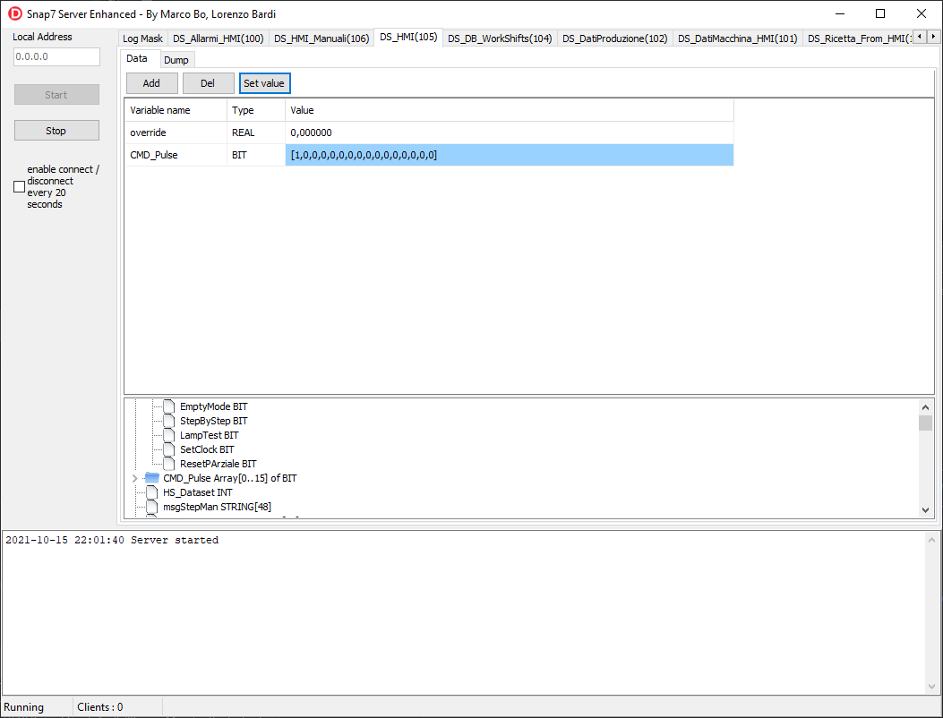

The table starts empty but you can add any variable to watch/edit selecting the desired variable on the DB tree and clicking the “Add” button or double clicking on it. To delete a variable from the watch/edit table just select it and click “Del” button.

If you click the “Set Value” button an input dialog will be shown and let you edit the actual value of the server variable selected.

Every S7 client reading the edited variable will read the new value.

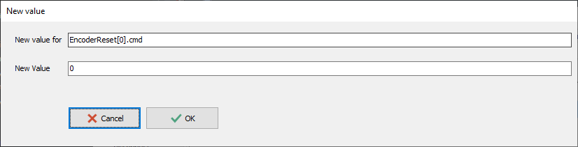

**Part 3 – License**

Copyright (C) 2021 Marco Giuseppe Bo  
Based from Snap 7 Server and Snap7 library from Davide Nardella

[Creative Commons License](http://creativecommons.org/licenses/by-sa/3.0/)  
This work is licensed under the [Creative Commons Attribution-ShareAlike 3.0 Unported License](http://creativecommons.org/licenses/by-sa/3.0/)  
Attribution required: please include our name in any derivative and let us know how you have improved it!